EXCEL

- Filtration Using Filter Tab in Data
- The longest movie in data sort by largest to smallest
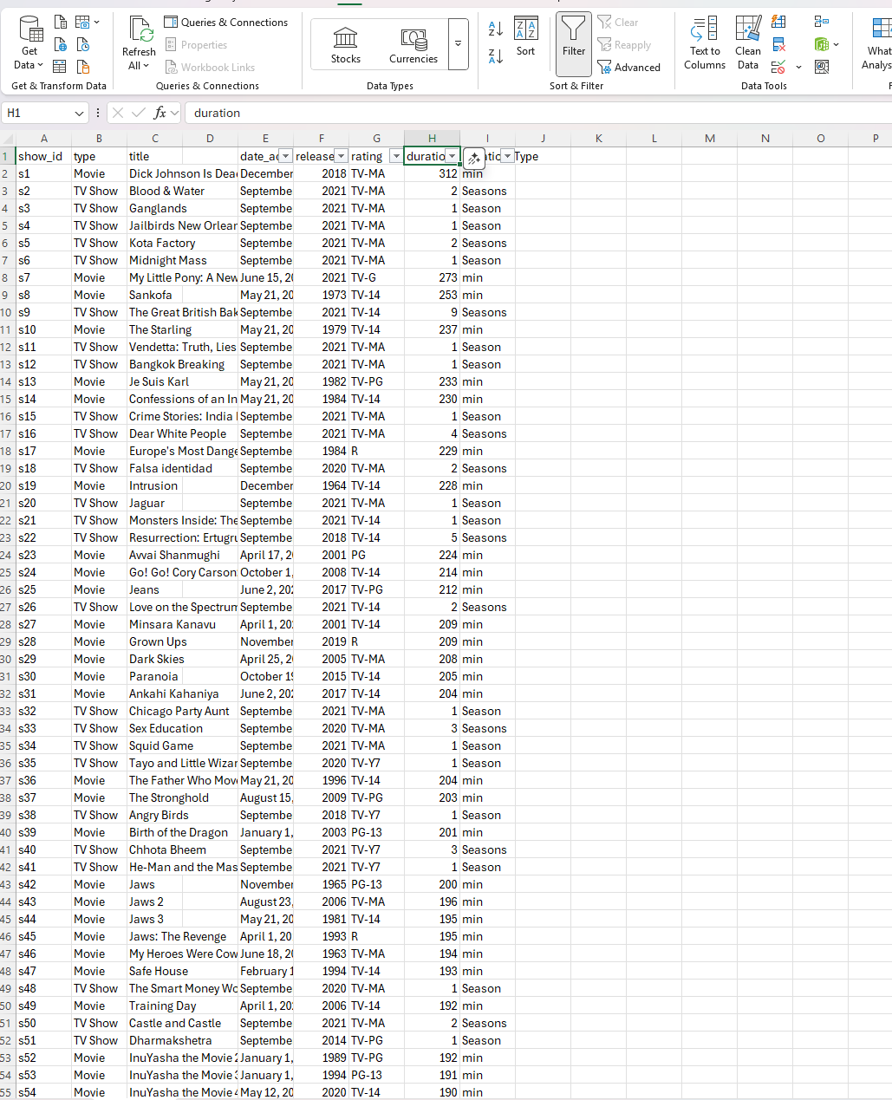
- Sort by Smallest to largest
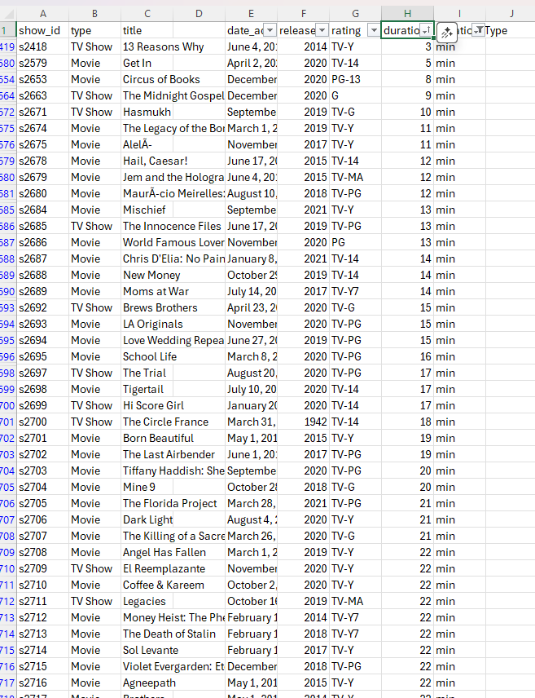
- SUM, MAX and Average Function to find the Total Length of movie uploaded in Netflix, Longest Movie and Average Minutes
